Object-Oriented Data Model

🧱 What is the Object-Oriented Data Model (OODM)?
# Source: AI Source: Provided by: [Data Path: Persons Table -> ID Column: 1, Name_En Column: Motasem Essam] -> From: [ChatGPT] on [6/10/2026]
The Object-Oriented Model is a type of data model that represents data as objects, similar to how you write programs in object-oriented languages like Java, C++, or Python.
📌 It combines the principles of databases and object-oriented programming:
You model data using objects, classes, inheritance, encapsulation, and methods.

🧠 Key Concepts
# Source: AI Source: Provided by: [Data Path: Persons Table -> ID Column: 1, Name_En Column: Motasem Essam] -> From: [ChatGPT] on [6/10/2026]
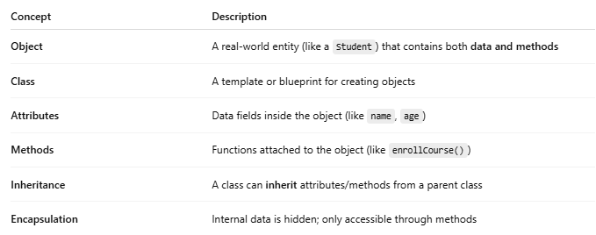
Concept | Description
Object | A real-world entity (like a Student) that contains both data and methods
Class | A template or blueprint for creating objects
Attributes | Data fields inside the object (like name, age)
Methods | Functions attached to the object (like enrollCourse())
Inheritance | A class can inherit attributes/methods from a parent class
Encapsulation | Internal data is hidden; only accessible through methods

👩‍🏫 Real-World Example: Student and Course

🎓 Object: Student
# Source: AI Source: Provided by: [Data Path: Persons Table -> ID Column: 1, Name_En Column: Motasem Essam] -> From: [ChatGPT] on [6/10/2026]
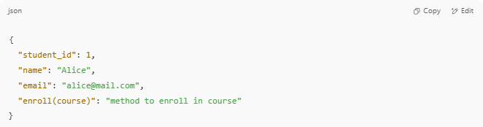
{
"student_id": 1,
"name": "Alice",
"email": "alice@mail.com",
"enroll(course)": "method to enroll in course"
}

📘 Class: Course
# Source: AI Source: Provided by: [Data Path: Persons Table -> ID Column: 1, Name_En Column: Motasem Essam] -> From: [ChatGPT] on [6/10/2026]
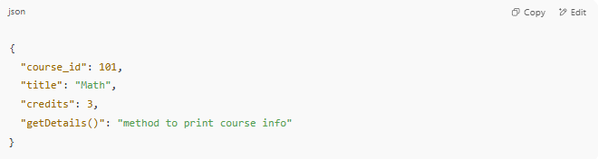
{
"course_id": 101,
"title": "Math",
"credits": 3,
"getDetails()": "method to print course info"
}

A Student object can call enroll() to join a Course.

🔁 OODM vs Relational Model
# Source: AI Source: Provided by: [Data Path: Persons Table -> ID Column: 1, Name_En Column: Motasem Essam] -> From: [ChatGPT] on [6/10/2026]
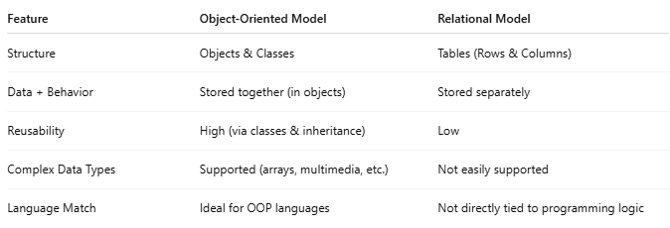
Feature | Object-Oriented Model | Relational Model
Structure | Objects & Classes | Tables (Rows & Columns)
Data + Behavior | Stored together (in objects) | Stored separately
Reusability | High (via classes & inheritance) | Low
Complex Data Types | Supported (arrays, multimedia, etc.) | Not easily supported
Language Match | Ideal for OOP languages | Not directly tied to programming logic

✅ Advantages of Object-Oriented Model
# Source: AI Source: Provided by: [Data Path: Persons Table -> ID Column: 1, Name_En Column: Motasem Essam] -> From: [ChatGPT] on [6/10/2026]
- 🌐 Better for complex applications (CAD, AI, simulations)
- 🔁 Reusability via inheritance
- 📦 Encapsulation increases modularity
- 🔍 Can handle multimedia, arrays, and user-defined types

❌ Disadvantages
# Source: AI Source: Provided by: [Data Path: Persons Table -> ID Column: 1, Name_En Column: Motasem Essam] -> From: [ChatGPT] on [6/10/2026]
- ⚙️ More complex to design than relational
- 📉 Not widely supported by traditional DBMS
- 📚 Learning curve is higher for beginners

🛠️ Example: Object-Oriented DBMS (OODBMS)
# Source: AI Source: Provided by: [Data Path: Persons Table -> ID Column: 1, Name_En Column: Motasem Essam] -> From: [ChatGPT] on [6/10/2026]
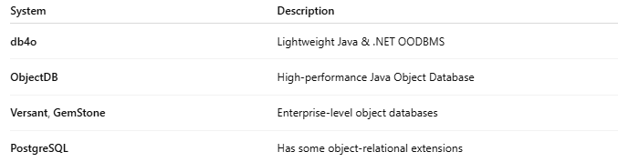
System | Description
db4o | Lightweight Java & .NET OODBMS
ObjectDB | High-performance Java Object Database
Versant, GemStone | Enterprise-level object databases
PostgreSQL | Has some object-relational extensions

🧠 Summary
# Source: AI Source: Provided by: [Data Path: Persons Table -> ID Column: 1, Name_En Column: Motasem Essam] -> From: [ChatGPT] on [6/10/2026]
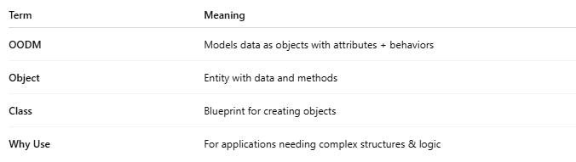
Term | Meaning
OODM | Models data as objects with attributes + behaviors
Object | Entity with data and methods
Class | Blueprint for creating objects
Why Use | For applications needing complex structures & logic

